Capitonyms

🔹 What Are Capitonyms
# Source: Chatgpt (GPT-4-turbo) at [8/1/2025]
Capitonyms are words that change meaning (and sometimes pronunciation) when capitalized.
The difference between the capitalized and uncapitalized form may involve:
- A proper noun vs. a common noun
- A place or person vs. a concept or object
Some capitonyms are also homophones if their capitalized and lowercase forms sound the same.

🧱 Key Features of Capitonyms
# Source: Chatgpt (GPT-4-turbo) at [8/1/2025]
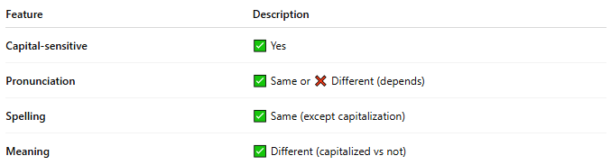
Feature | Description
Capital-sensitive | ✅ Yes
Pronunciation | ✅ Same or ❌ Different (depends)
Spelling | ✅ Same (except capitalization)
Meaning | ✅ Different (capitalized vs not)

📝 Examples of Capitonyms
# Source: Chatgpt (GPT-4-turbo) at [8/1/2025]
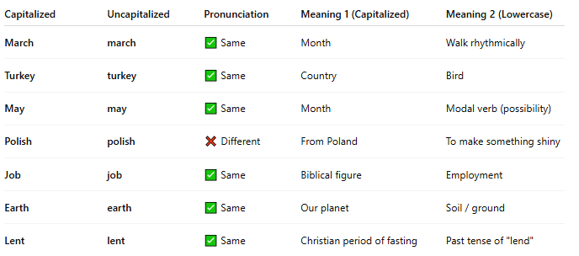
Capitalized | Uncapitalized | Pronunciation | Meaning 1 (Capitalized) | Meaning 2 (Lowercase)
March | march | ✅ Same | Month | Walk rhythmically
Turkey | turkey | ✅ Same | Country | Bird
May | may | ✅ Same | Month | Modal verb (possibility)
Polish | polish | ❌ Different | From Poland | To make something shiny
Job | job | ✅ Same | Biblical figure | Employment
Earth | earth | ✅ Same | Our planet | Soil / ground
Lent | lent | ✅ Same | Christian period of fasting | Past tense of "lend"

🧭 Are Capitonyms Homophones?
# Source: Chatgpt (GPT-4-turbo) at [8/1/2025]
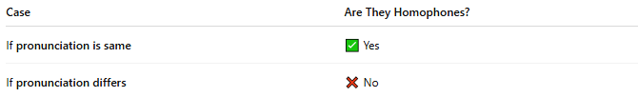
Case | Are They Homophones?
If pronunciation is same | ✅ Yes
If pronunciation differs | ❌ No
So:
- March/march, May/may, Job/job → ✅ Homophones
- Polish/polish → ❌ Not homophones (pronounced differently)

🧠 Why Are Capitonyms Important?
# Source: Chatgpt (GPT-4-turbo) at [8/1/2025]
- They illustrate the importance of capitalization in English.
- Can create humorous or poetic ambiguity.
- Common in wordplay, puns, and riddles.

🎯 Capitonym Wordplay Example
# Source: Chatgpt (GPT-4-turbo) at [8/1/2025]
"In March, I like to march."
"She tried to polish her accent like a true Polish native."

